**FoodBox**

Phase 5 Assessment

Screenshots

Name: Harshitha G M

Cohort: MS FSD June 2022 Cohort 3

GitHub link: https://github.com/HarshithaGM01/Phase-5-Foodbox.git

Contents.

* 1. Project Outputs 3

***1. Project Outputs.***



A. Home Page.

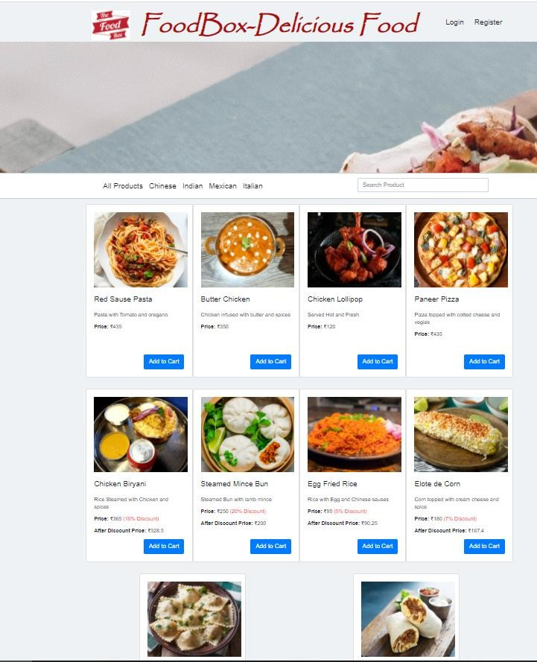



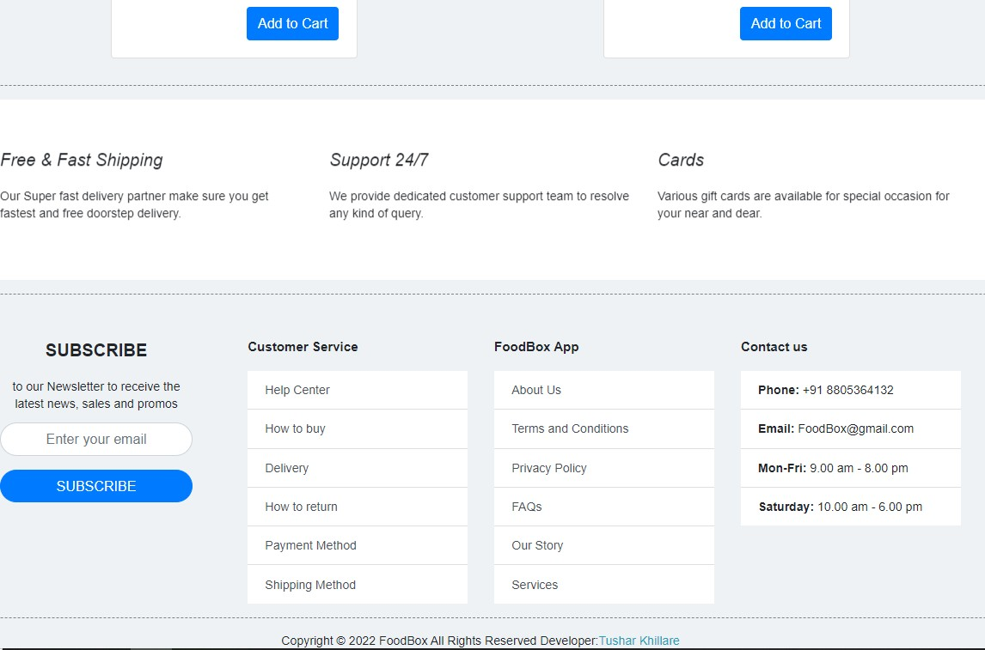





B. Login and Registration Page.

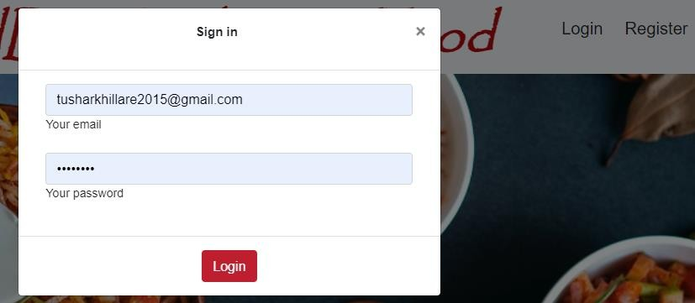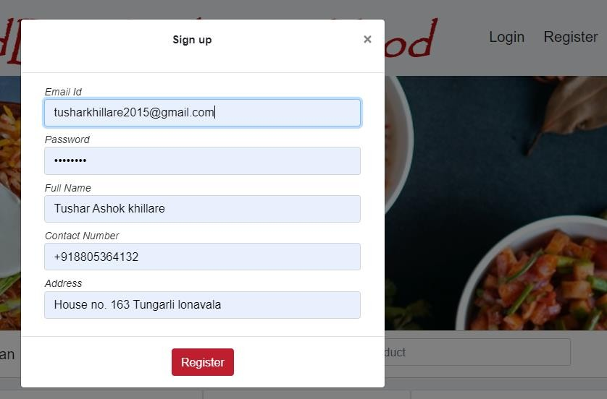





C. Admin Login Page.

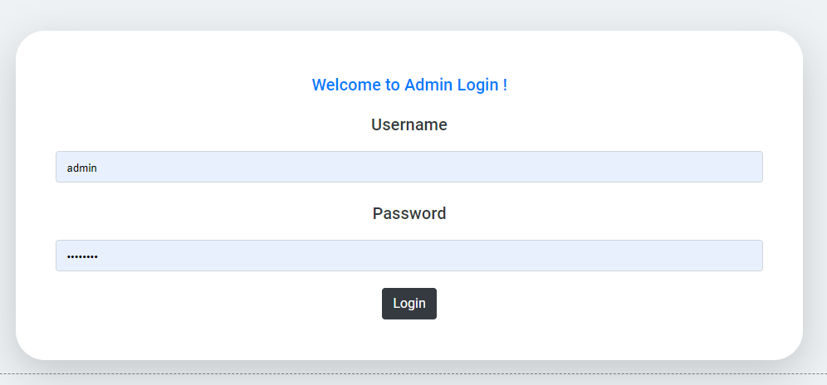

D. Manage Users , Products , Purchases.

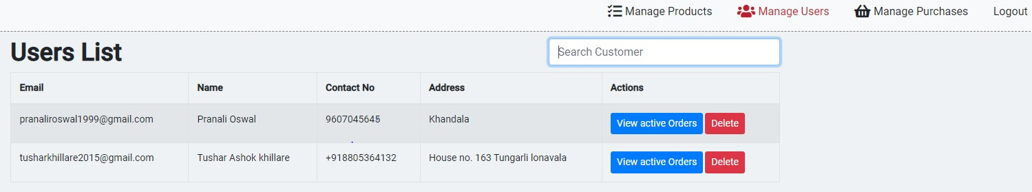

Searching and Sorting:

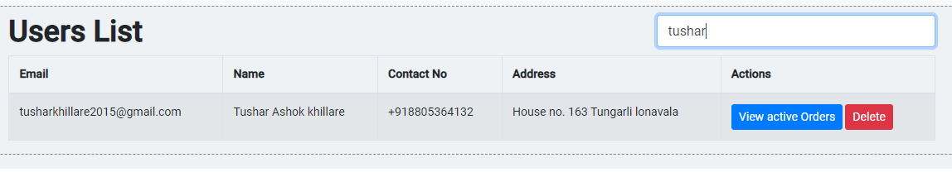

Manage Products:

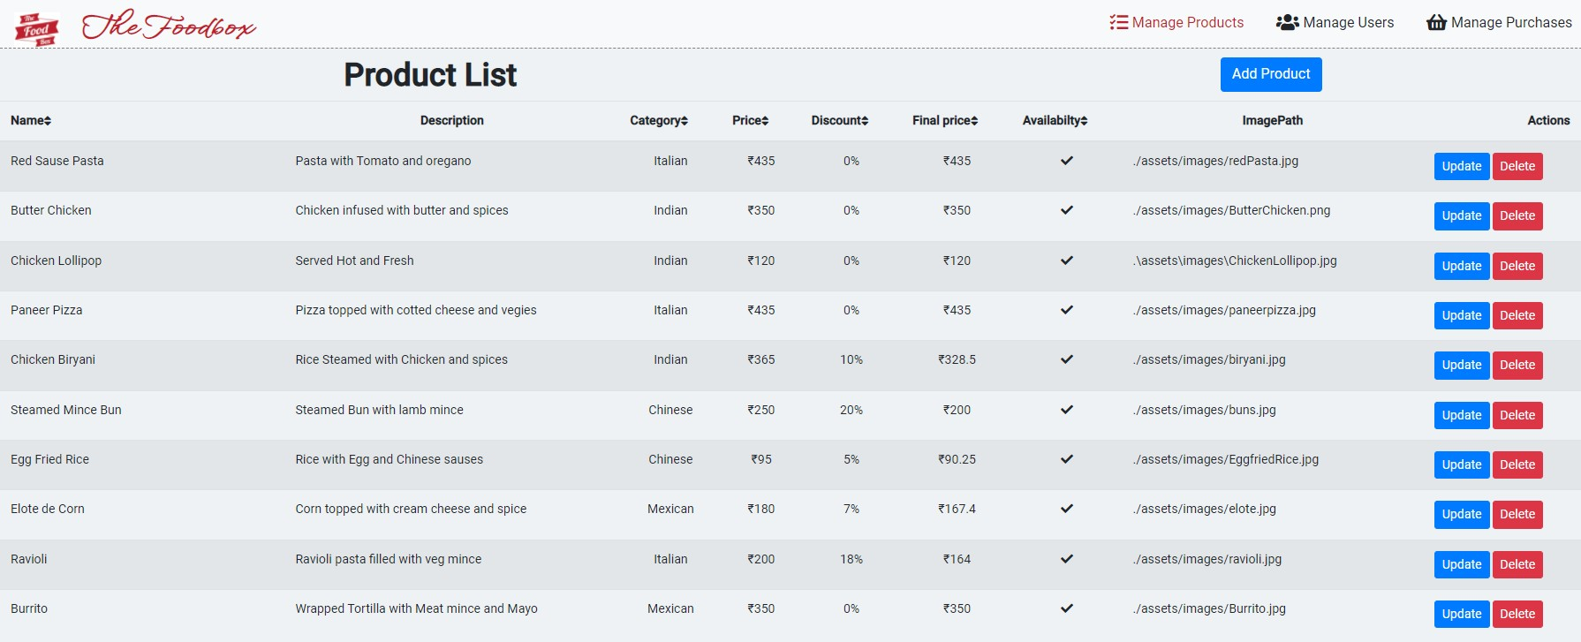

Add Product:

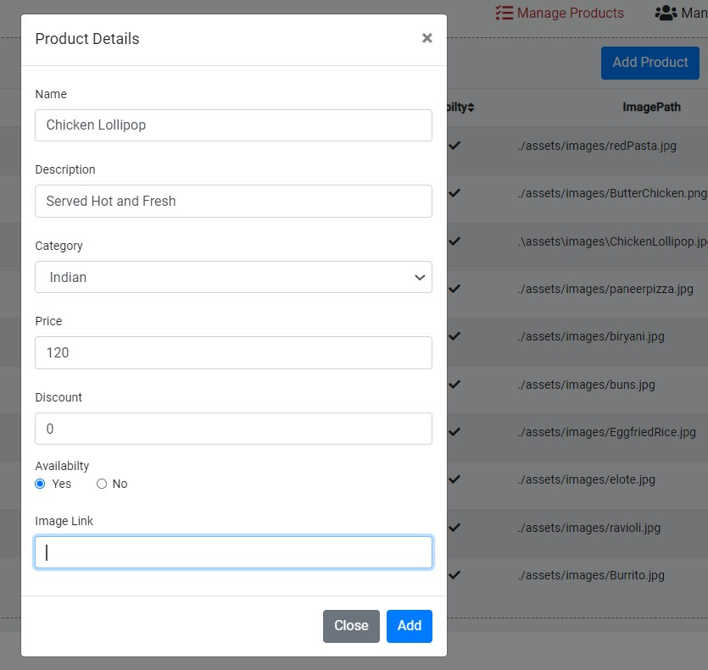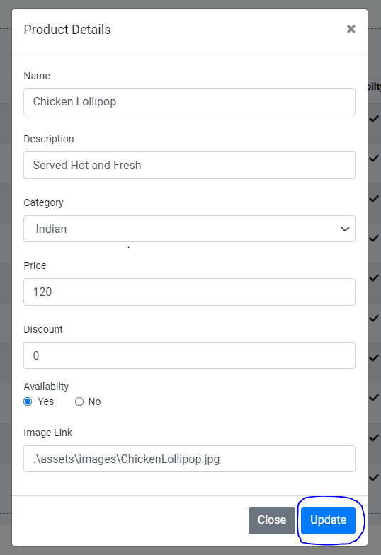

Update Product:

Delete Product:

Product deleted successfully…..

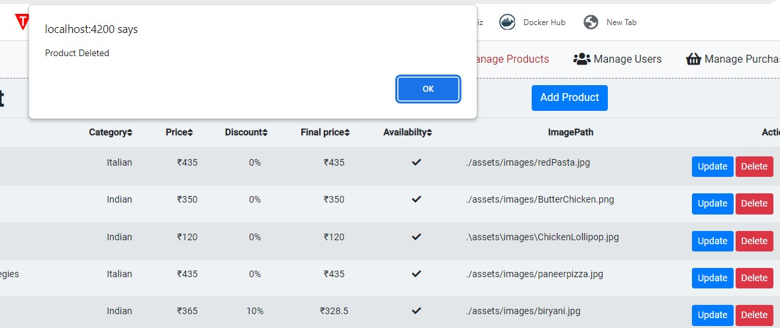

Manage Purchases:

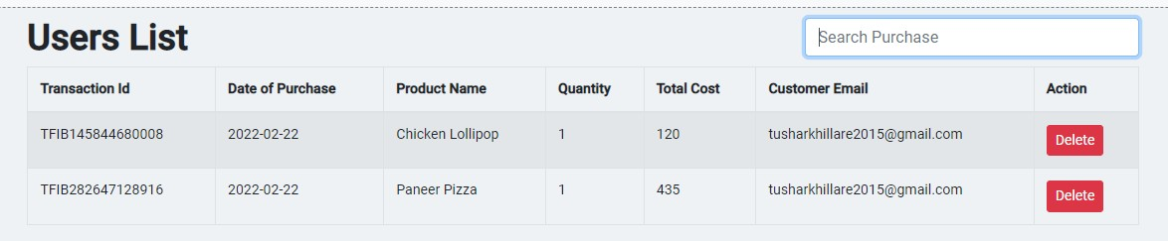





E. View Previous Active Orders.

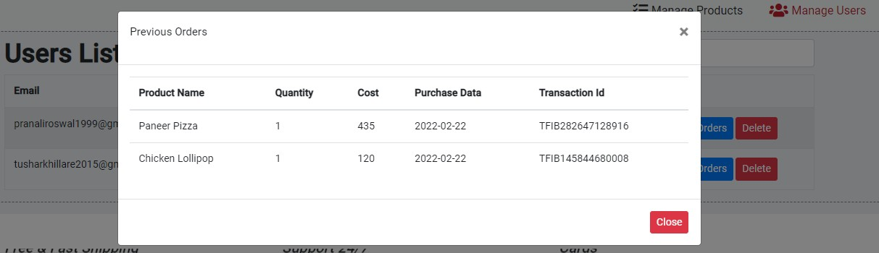

F. User Login.

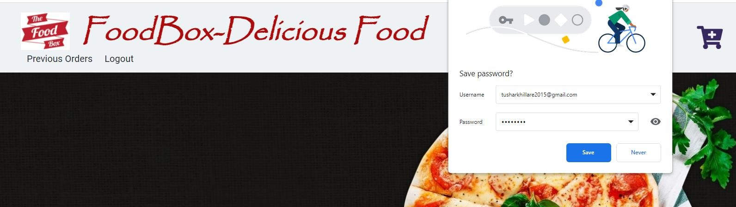

G. Add Cart / View Cart.

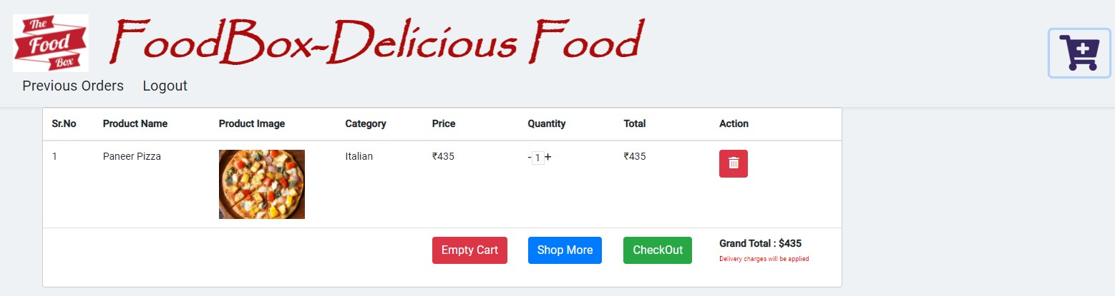

My Cart:

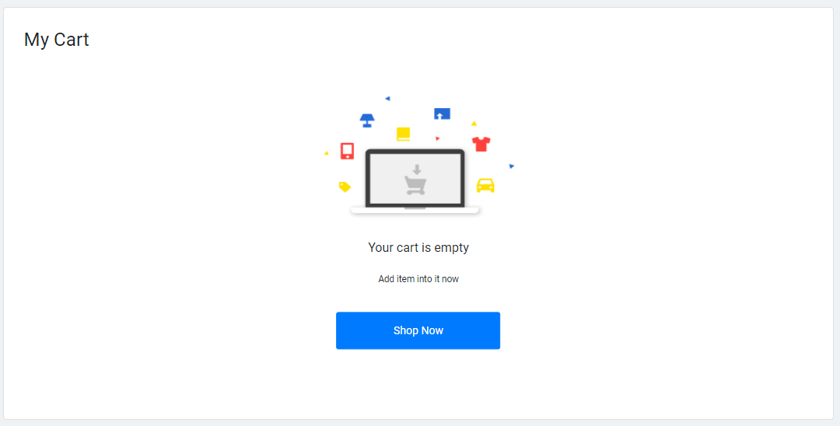

H. Payment Gateway Page.

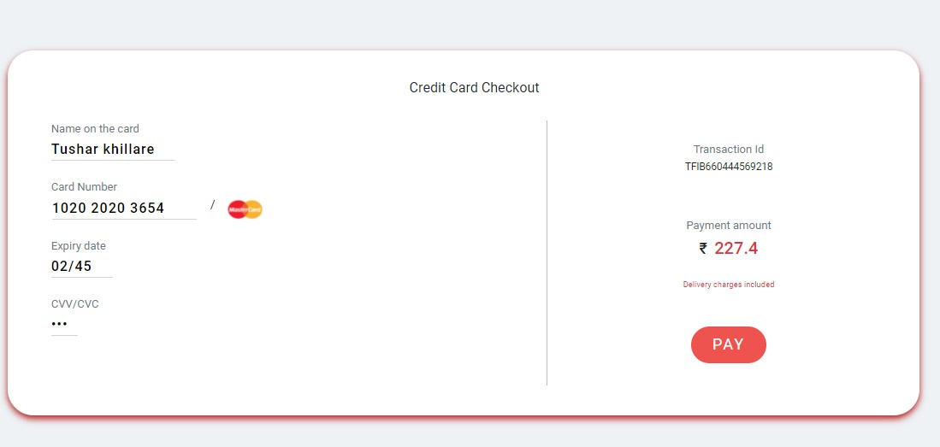

Payment Status:



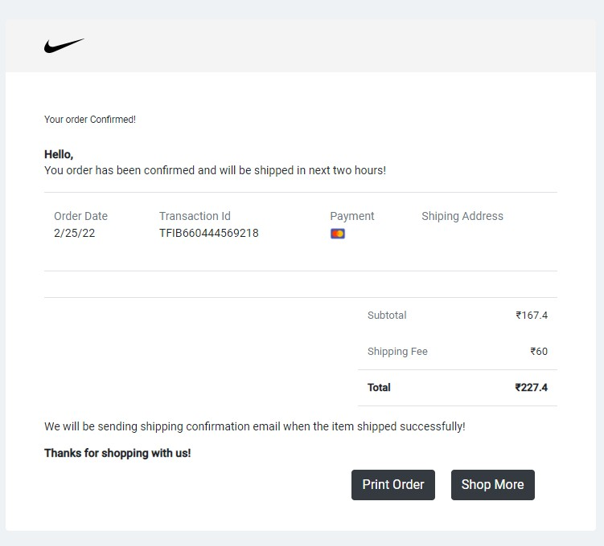

**TESTING AND DEVOPS USING JENKINS**

*Jenkins Build triggered successfully:*

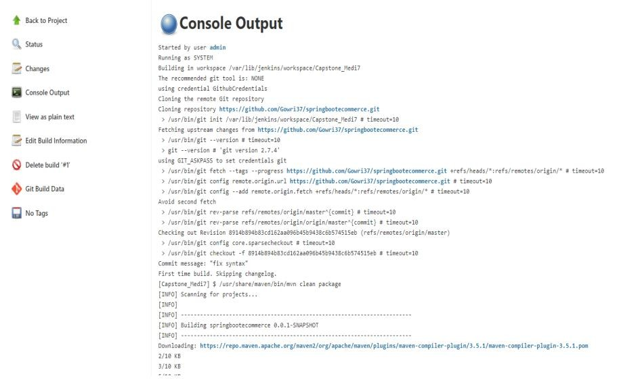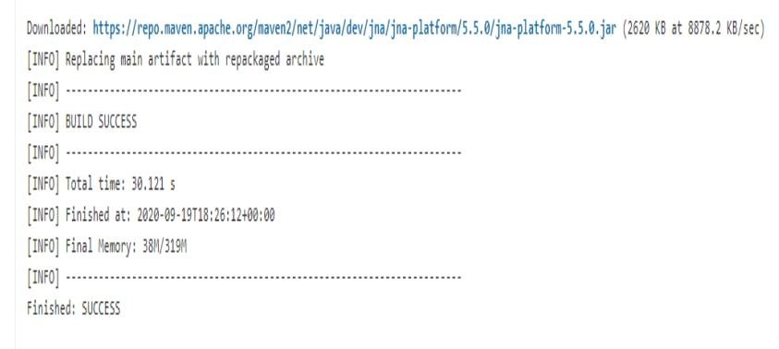

**PROJECT SCREENS POST TESTING AND JENKINS DEPLOYMENT**:

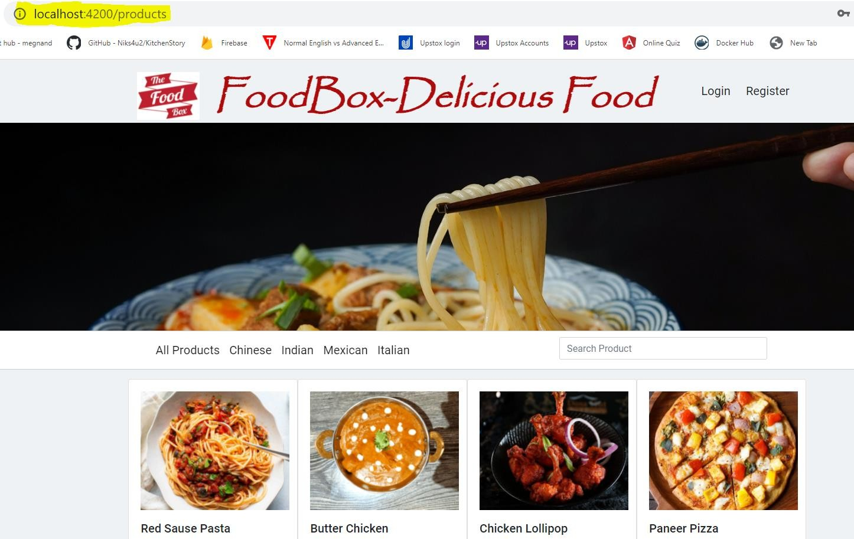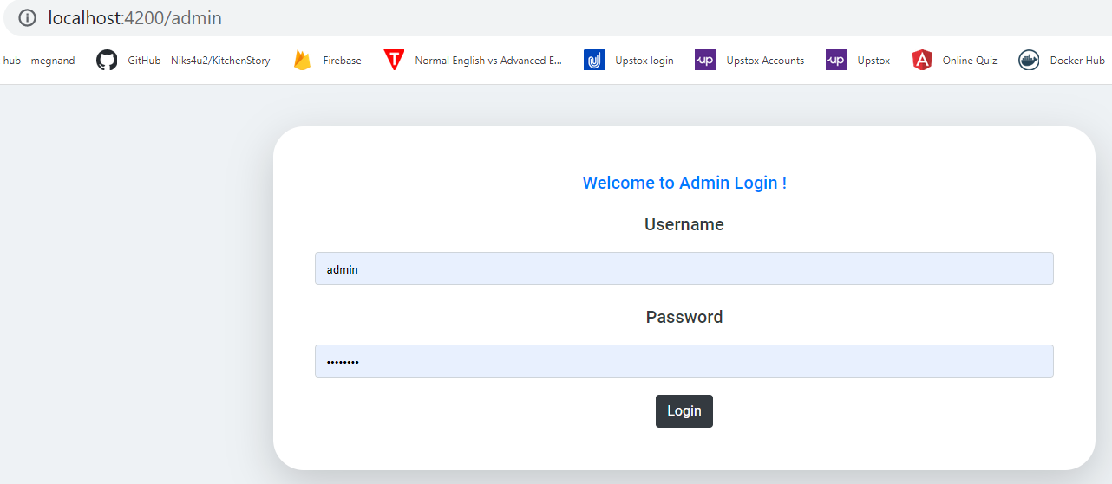

Category Based Searching

http://localhost:4200/products

15

THANK YOU……………

16